The Evolution of Vernalisation in Flowering Plants

* Physiological response of vernalisation
* Effects of vernalisation
* Defined as “SEED cold treatment”

GLOBALS:

* Use SPECIFIC examples to illustrate points rather than large, sweeping statements
* Rewrite so as not to include “It is known, therefore, however” and other redundant bridging words

The Vernalisation Response

Vernalisation (from the Latin *vernum*, meaning *spring*), and its effect on harvest time and crop yield, has been a central research focus of the plant biology community for over 150 years, with early studies focused on cereals (Klippart 1857; Gassner 1918). Vernalisation is characterised by a prolonged (i.e. greater than ten days) exposure to low but non-freezing temperatures, but the temperature at which vernalisation occurs is dependent on the plant species and variety. Narrow Leaf Lupin (*Lupinus angustifolius*) expresses a vernalisation response at temperatures between 3oC and 7oC (Landers 1995), whereas the temperature used to research vernalisation in *Arabidopsis thaliana* (*Arabidopsis*) is 4oC (Burn et al. 1993; Bastow et al. 2004). Vernalisation temperatures for barley range from 8oC (Trevaskis et al. 2006) right down to 2o C (Oliver et al. 2009). The threshold temperature that triggers a vernalisation response in a plant species can be determined by examining the rate of plant growth under varying temperatures, then selecting a temperature a few degrees above the inferred basal temperature (Angus et al. 1980). In some plant varieties, such as sugar beet (*Beta vulgaris*) and carrot (*Daucus carota*), the plant must be exposed to vernalisation conditions before the plant can flower (an *absolute* vernalisation requirement). In plant species and varieties where vernalisation is not essential for the transition to flowering (a *facultative* vernalisation requirement), vernalisation decreases the time it takes for this transition to occur. In the *facultative* vernalisation sensitive *Arabidopsis* ecotype “C24”, the resultant decrease time to flowering is directly proportional to the length of vernalisationexposure (Sheldon et al. 2000). The regulatory pathways and genetic mechanisms of vernalisation are family-specific, not just between dicotyledous (dicots) and monocotyledous species (monocots), but also within different dicots (Reeves et al. 2007). Despite these differences, the gene pathways in vernalisation responsive plant species are epigenetic and mechanistically related, i.e. a vernalisation sensitive variety of a plant species will resulting in expression of a different phenotype when exposed to vernalisation environmental cues. These epigenetic changes are reset with the next generation.

In *Arabidopsis* and other dicots, the SAM is located at the crown of the plant and is composed of a collection of pluripotent stem cells that slowly divide and differentiate into the various progenitor cells necessary for vegetative tissue growth (Meyerowitz 1997; Fletcher 2002). In *Poa pratensis* (Kentucky Bluegrass) and other monocots, the location of the pluripotent stems cells are in the basal meristem at the bottom of the plant, just above the soil line. Regardless of location, after floral induction, the types of progenitor cells that the meristem stem cells produce changes into those progeny cells necessary for the creation of tissues and structures for flowering. In 1962, Wellensiek (Wellensiek 1962) showed that in a number of plants with a SAM, moving vernalised shoot stock to non-vernalised root stock resulted in a vernalised plant. Similarly, moving non-vernalised shoot stock to vernalised root stock did not result in a vernalised phenotype, meaning that while other organs may respond to vernalisation, the most profound location for phenotypic expression of vernalisation in dicots is the shoot tip containing the SAM, which contains the shoot apical meristem. Presumably, a similar effect would be seen in monocots, where grafting a basal meristem of a vernalised plant onto non-vernalised root stock would result in an expressed phenotype showing exposure to vernalisation, and vice versa. However, the literature is not clear in this regard.

Vernalisation in Arabidopsis <1 page>

In *Arabidopsis*, the MADS-box transcription factor Flowering Locus C (FLC) is the key mediator in the transition to flowering. *FLC* expression is promoted by *FRIGIDA* (*FRI*), *FRIGIDA-LIKE 1* (*FRL1*) and *FRIGIDA-LIKE 2* (*FRL2*) (Werner et al. 2005). While *FLC* is expressed, it represses *Flowering Locus T* (*FT*) expression (Sheldon et al. 2000). In the *Arabidopsis* ecotype *Col*-0, during FLC expression, VERNALISATION 2 (VRN2) binds with CURLY LEAF (CLF), SWINGER (SWN) and FERTILIZATION-INDEPENDENT ENDOSPERM (FIE) to form the VERNALISATION 2 (VRN2)/Plant Homeo domain Polycomb Repression Complex 2 (PHD-PRC2) (Köhler & Villar 2008). This protein complex is constitutively bound to the *FLC* locus, maintaining the locus in an open conformational shape via H3 acetylation and allows transcriptional machinery to access the *FLC* regulatory sequence and promote *FLC* expression (De Lucia et al. 2008).

When *Col*-0 is exposed to non-freezing cold, this triggers expression of *VERNALISATION INSENSITIVE 3* (*VIN3*), *VERNALISATION 5/VIN3-LIKE* (*VEL1*) and *VERNALISATION 5* (*VRN5*). The resulting proteins bind to the VRN2/PHD-PCR2 complex to promote histone H3 deacetylation and *VRN2*-directed trimethylation of H3K9 and H3K27 at the *FLC* locus. This closes the conformational shape of *FLC*, blocking transcriptional machinery from accessing *FLC*, thereby repressing expression (Finnegan & Dennis 2007). This epigenetic repression of *FLC* is stable and irreversible, ensuring the transition to a flowering state is permanent (Levy et al. 2002; Sung & Amasino 2004). <Something about C24 having “more” FLC than *Col*-0, therefore needing more exposure to vernalisation to achieve the same stable repression? Assuming C24 has a higher level of FLC…>

When the *FLC* locus is closed, *FLOWERING TIME* (*FT*) can then be expressed in leaf tissues. FT travels through the phloem and into meristem tissues (Corbesier et al. 2007). Once there, FT triggers floral induction by transitioning meristem cells to a reproductive state by promoting *LEAFY* (*LFY*) and *APETALA1* (*AP1*), the two primary promoters of floral apical

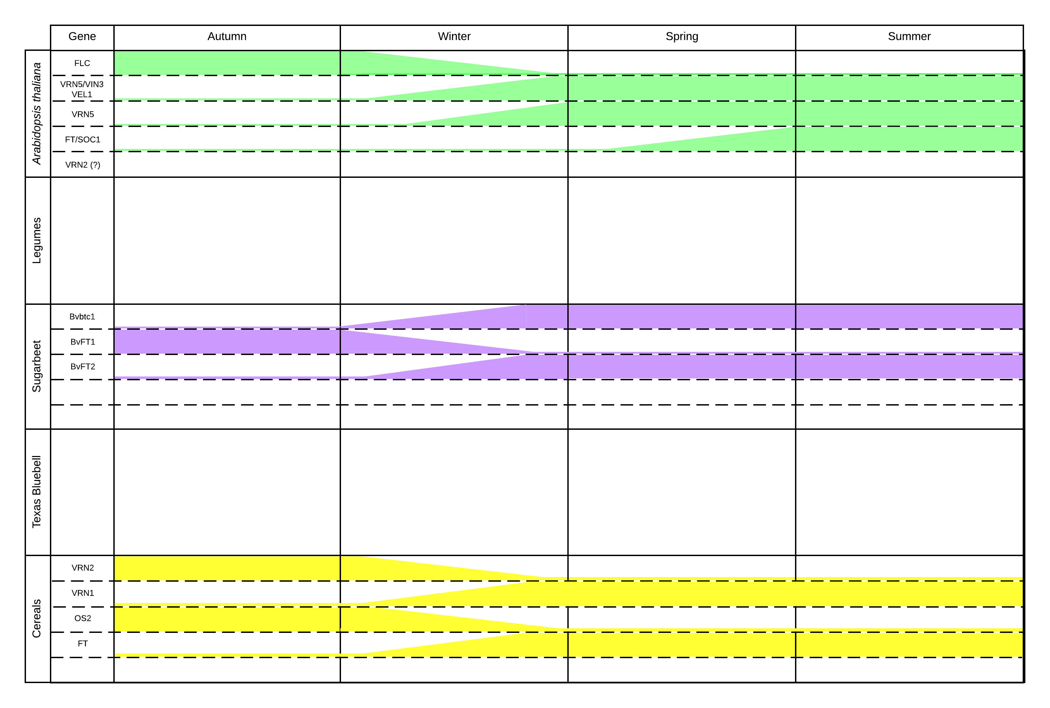

meristem growth (Amasino 2004). These then cause pluripotent cells in the SAM to differentiate and divide into reproductive tissues and eventually flowering bodies.

* NB: Finnegan 2005 says DNA methylation does NOT contribute to vernalisation and repression of FLC! Countered by Lee et al 2015 (expression of DNA methyltransferase and timing of vernalisation?)
  + NB: One is Chromatin Methylation and the other is DNA methylisation. Reread both these papers.
  + Histone H3K9|27 represses with VRN2 FLC – Sung and Amasino 2004
  + Histone H3K4 demethylation in promoter region (Finnegan 2005)
  + DNA methylation does NOT change FLC expression(Sheldon 2002)
  + Histone H3 deacetylation BEFORE methylation?

(Boss et al. 2004)

* NB: Having difficulty here. C24 appears to be a cultivar that has unusually high levels of FLC, which means it is vernalisation sensitive. However, I can’t seem to tease out whether *Col*-0 is vernalisation sensitive AS WELL or whether it and C24 are similar, they just have differing levels of FLC and therefore C24 needs “more vernalisation”.

VIN3 – Loss of function mutant, tends to directly relate to detection of cold (Sung & Amasino 2004). Is this worth incorporating or is it going a little too far “outside of the scope”?

This in turn represses the expression of *FLOWERING TIME* (*FT*), the FT homolog *TWIN SISTER OF FT* (*TSF*), and *SUPPRESSOR OF OVEREXPRESSION OF CONSTANS 1* (*SOC1*).

Natural variation in regulators of FLC (frigid) or FLC itself modify vernalization requirement of Arabidopsis ecotypes. Would leave this until finished with FLC function. (Werner et al. 2005)

Vernalisation Response in Legumes – ½ page

There are a number of *Fabaceae* (legume) genera that respond to vernalisation. *Medicago truncatula* contains three classes of *FT* genes, *FTa* *FTb* and *FTc,* that are conserved across the *Fabaceae* but are not found in any other angiosperm (Hecht et al. 2011). Five *FT-like* genes exist in *M. truncatula*; *MtFTa1*, *MtFTa2*, *MtFTb1*, *MtFTb2* and *MtFTc* (Laurie et al. 2011). Of these, overexpression of *MtFTa1* occurs in the spring mutant of *M. tuncatula* (Putterill et al. 2013). But in the wild type, *MtFTa1* overexpression is only seen after exposure to vernalisation conditions (Jaudal et al. 2013). *Medicago* species also appear to lack an *Arabidopsis* *FLC* or *MAF* homolog (Hecht et al. 2005), but contains *MtFRI-like*. When *MtFRI-like* was transformed into the *Arabidopsis* variety Col-*0*, flowering was delayed, indicating *MtFRI-like* has a similar functional homology to *AtFRI* by promoting the expression of *FLC* (Chao et al. 2013).

Other members of the of *Fabaceae* also respond to vernalisation. The vernalisation response in pea (*Pisum*) has been known for some time . More recently, research in the *Lupinus* genus, (namely *L. albus*, *L. augustifolius* and *L. luteus*) has shown a similar vernalisation response (Gladstones & Hill 1969; Landers 1995). In both *Pisum* and *Lupinus*, similar to *Arabidopsis*, the decreased in time to flowering is proportional to the time the seedlings have been exposed to vernalisation conditions. While the exact mechanisms for this phenotypic response have not been confirmed in these genera, it could be surmised that homologs of the *MtFT* family will play a central role, similar to *Medicago*.

Even with the absence of the MADS-box genes *FLC* and *MAF1* through *MAF5*, critical to the vernalisation response and flowering time in *Arabidopsis*, the *Fabaceae* are still able to response to vernalisation environmental cues, as seen in overexpression of *MtFTa1* and *MtFRI-like*. While these have been shown to be functional homologs in *Arabidopsis*, the exact mechanism of these regulators in legumes are yet to be characterised.

<Vernalisation in Texas Bluebell? – ½ page>

Texas Bluebell (*Eustoma grandiflorum* and *Eustoma russelianum*) is an ornamental flowering plant native to the southern United States, Central America and the northern regions of South America. *Eustoma* have a similar vernalisation response to *Arabidopsis* and *L. augustifolius*, where the time to bolting is shortened in proportional to the amount of cold exposure (Pergola 1992). *Eustoma* contains homologs to *Arabidopsis* FLC, FT and SOC1 (EgFLCL, EgFTL and EgSOC1L respectively). While EgFTL and EgSOC1L appear to be functional homologs of their *Arabidopsis* counterparts, being lowly expressed until restoration of indiuctive photoperiod post vernalisation, when the expression levels of EgFTL and EgSOC1L increase. However, EgFLCL appears to be lowly expressed during vegetative growth and only increases with the onset of vernalisation, the opposite of what is observed in *Arabidopsis* (Nakano et al. 2011). This may indicate that the function of EgFLCL is closer to that of MAF5 in *Arabidopsis* than other MADS-box containing transcripts such as FLC or MAF2-5 (Ratcliffe et al. 2003). This may mean that rather than directly repressing the expression of EgFTL, EgFLCL may restrict the expression of a geen target which in itself repressed EgFTL in *Eustoma*.

<Vernalisation in Sugarbeet – ½ page>

Sugar Beet (*Beta vulgaris* ssp. *Vulgaris*) is cropped for its large sucrose rich root organ. Early studies of demonstrated the necessity for photothermal induction (i.e. exposure to vernalisation conditions followed by increased day length) for flowering (Owen et al. 1940). Because of the absolute requirement for vernalisation for flowering, breeders have selected for phenotypes that maintain the vegetative and root growth state so as to maximise root yield. Recent studies have characterised the molecular mechanisms underpinning the vernalisation response in beet as distinct from other species (Pin et al. 2012). Two paralogous *Flowering Locus T* (*FT*)genes, *BvFT1* and *BvFT2*, central to the regulation of flowering, are controlled by *BOLTING TIME CONTROL 1* *FLOWERING TIME 1* (*FT1*) is responsible for regulating *FLOWERING TIME 2* (*FT2*),(Pin et al. 2010). Rather than a single *FT* gene responsible for triggering flowering time controlled by FLC, as seen in *Arabidopsis* (*BvBTC1*). In biannual sugar beet, it is the recessive allele of *Bvbtc1* that produces a phenotype with an absolute vernalisation requirement. While the vernalisation pathway in *B. vulgaris* is distinct from *A. thaliana*, it also containsa number of homologous pathways, including the photoperiod pathway (Chia et al. 2008) and the autonomous pathway (Abou-Elwafa et al. 2011). However, these pathways are yet to be fully characterised in sugar beet.

<Vernalisation in Cereals – 1 page>

* Focus for this section should be:
  + Intro to different system in cereals
  + VRN1 and its effects
  + VRN2 and its effects
  + VRN3 (FT) and its effects
  + Context as to why variations in each of these is important

Monocots, such as bread wheat (*Triticum aestivum*), barley (*Hordeum vulgare*) and *Brachypodium distachyon* (a model monocot) have a vernalisation pathway that differs greatly from *Arabidopsis* and other dicotyledonous species (dicots). While there are a number of mechanisms conserved between monocots and dicots, the most notable difference in cereals is the absence of a known homolog for AtFLC. Instead, the interplay between VRN1 (a MADS-box transcription factor), VRN2 (a zinc-finger motif with CCT domain, which in cereals is distinct from AtVRN2 (Yan et al. 2004)) and VRN3 (a homolog of AtFT) (Trevaskis et al. 2007)

Before wintering, the cereal remains in a state of vegetative growth due to the presence of HvVRN2, which represses *HvFT* expression (Ream et al. 2014). The floral repressor, ODDSOC2 (OS2), also present at high levels in winter cereals prior to vernalisation, maintains the cereal’s vegetative growth state (Greenup et al. 2010). Once exposed to vernalisation conditions, winter barleys increase expression of *HvVRN1* via lower H3K27me3 and higher H3K4me3 levels in the *HvVRN1* locus. This opens the histone conformational shape, allowing *VRN1* expression (Oliver et al. 2009). Similar to *FLC* in *Arabidopsis*, this change is stable, but in winter barley, the shape change allows access (rather than restricting access) to the *HvVRN1* gene. Increased levels of HvVRN1 in turn repress expression of *HvVRN2*. Low HvVRN2 levels promote *HvFT* expression, triggering the transition of the winter barley to flowering (Trevaskis et al. 2006). Exposure to vernalisation conditions and the presence of HvVRN1 also stably inhibits the expression of *OS2*. Lower levels of OS2 promote the expression of *FPF1*, which in turn promotes the transition to a flowering state.

<Phylogenies – ½ page>

Approximately 34 million years ago, <mass extinction at the Eocene/Oligocene boundary – Further describe> (Silva & Jenkins 1993). It is hypothesised that this event cause a divergence of a number of plant species <blah blah blah>from acclimatisation of tropical environments to temperate ones (Ivany et al. 2000).

Is there a previous boundary before this that could also contribute? The E/O boundary being the most recent?

However, in terms of a response to cold climates (and hence response to vernalisation). What is the evolutionary timeline for flowering plants?

* + NB: You will need to expand on this and describe HOW the stuff in Figure 3 is built (Preston & Sandve 2013)
  + Even though *Brassicales* and *Fabaceae* are the closest evolutionary-wise, the *Fabaceae* don’t have the FLC gene. *Fabaceae* lost it rather than *Brassicale* gaining it?
  + Monocots furthest away phylogenetically as well as physiologically (basal meristem). Makes sense the genetics are different as well.
  + Eustoma and Asteraceae reasonably close, hence both containing FLC? Make an inference that this is the case. Anything on sunflower/lettuce and FLC?
    - Which is older? Eustoma or Asteraceae?
  + Why then is sugar beet so different to the Eustoma and Asteraceae?
* <combine phylogenies with physiological response – Fig 1>

<Whole Genome Sequencing – ½ page>

* Enabling technology for elucidating genes and gene pathways

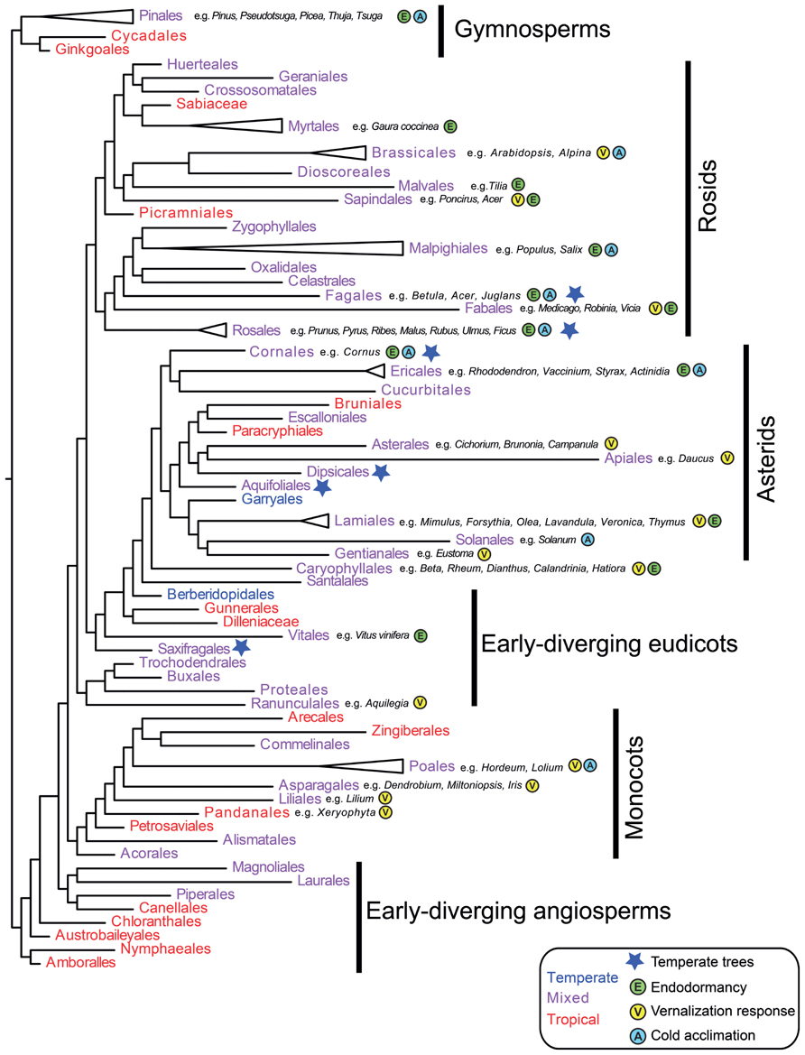

Figure 3 – Phylogenetic tree of different seed producing plant families, taken and adapted from (Preston & Sandve 2013). Individual members of represented families examined in this review have been indicated with a grey box around the family name and attributes.

<Vernalisation in Asteraceae>

While much research has been undertaken with regards to the vernalisation response in major crop species and *Arabidopsis*, current research regarding the vernalisation response in safflower, and indeed, other members of the *Asteraceae* family, one of the largest and most diverse of the flowering plant families, is relatively scarce. Early research in lettuce (*Lactuca sativa*) observed that germinated seeds that were vernalised prior to planting responded by bolting up to four weeks earlier than unvernalised seeds (Figure 3) (Gray 1942; Warne 1947; Rappapport et al. 1956). Later studies indicated that in response to vernalisation temperature cues and extending day length, However, without these cues, lettuce still transitioned to flowering, indicating a *facultative* vernalisation response, similar to *Arabidopsis* (Waycott 1995). While this research focused on the expressed phenotype under vernalisation conditions, the genetic mechanisms of vernalisation weren’t explored until much later on.

Chicory (*Cichorium intybus*), is an *Asteraceae* with an absolute vernalisation requirement. It has been demonstrated that when exposed to vernalisation conditions, chicory expresses CiFL1, a MADS-box transcription factor with significant sequence homology to AtFLC (Périlleux et al. 2013). When *CiFL1* was transformed into *Arabidopsis* and over expressed, the mutants showed a significant delay in onset of flowering, regardless of vernalisation exposure, indicating a similar molecular pathway effect between CiFL1 and AtFLC.

Early studies in safflower indicate a relationship between photoperiod, vernalisation and a decrease in the time to flowering in some safflower varieties (Zimmerman 1973). However, as mentioned above, the limited availability of genetic resources for the *Asteraceae* make characterisation of molecular pathways and mechanisms in these species challenging. As further resources become available and are annotated, the mechanisms by which vernalisation, and other factors, affect flowering time will be better understood. While an FLC homologue may be present in many species, based on what is seen in *Eustoma*, its effects on the vernalisation response in *Asteracese* may not be the same as what is seen in *Arabidopsis*.

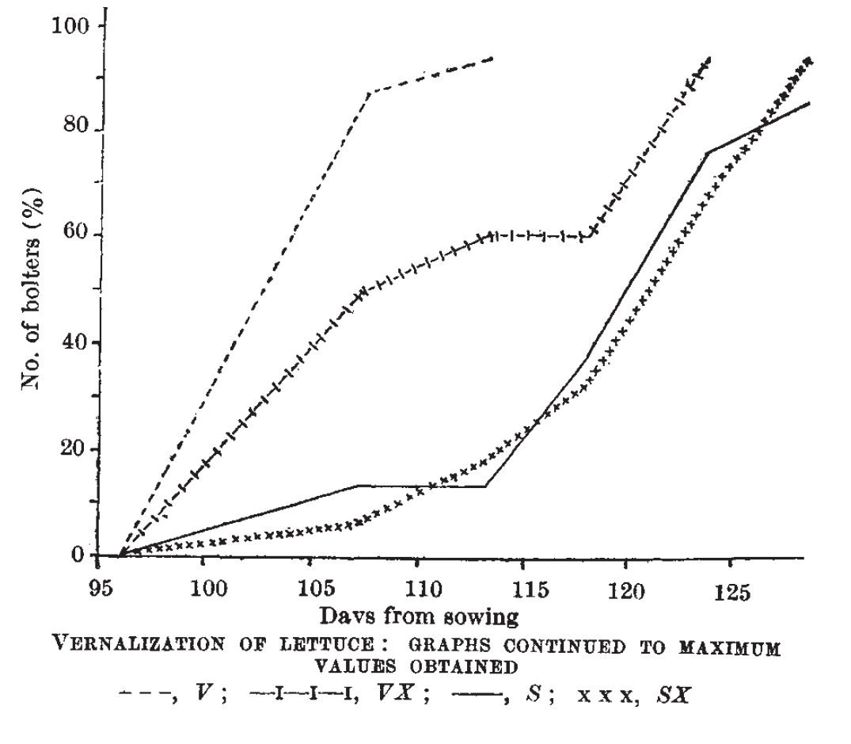

Figure 3 – The effect of vernalisation on days to bolting in lettuce, taken from (Warne 1947)

Conclusions

In most plant species, the presence of a vernalisation response has been known for quite some time. While the phenotypic response to vernalisation is consistent between different facultative or absolute vernalisation species, the underlying genetic mechanisms differ substantially. During vernalisation, in *Arabidopsis*, FLC expression is repressed via <histone methylation and demethylation>, allowing the expression of FT and downstream genes. However, in barley, repression of VRN2 by VRN1 allows the expression of the FT homolog VRN3, allowing the transition of barley to flowering. Sugar beet has a different mechanism again, expressing two conunteracting FT homologs (BvFT1 and BvFT2). It has also been shown that while both *Eustoma* and *Arabidopsis* both express homologs of FLC, its action in *Eustoma* is the opposite in the vernalisation response when compared to *Arabidopsis*. Perhaps the role of FLC (and other MADS-box transcription factors) as a repressor of FT is unique to the *Brassicaceae.*

In the plant varieties above that respond to vernalisation, FT (or its variants) are expressed in true leaf tissue, with the downstream targets expressed in the shoot apical meristem. While the downstream effects of extended cold exposure can be observed in the phenotypic vernalisation response, the mechanisms of how plants detect cold in the first place is still poorly understood and difficult to elucidate. It was believed that with the rapid expansion of gene expression analysis, these mechanisms would become clear. But while this technology has provided an amazing insight into, such fundamental questions such as the mechanisms that plants use to detect exposure to cold are still yet to be answered.

**References**

For submission to trends in Plant Science – NB: Mendeley referencing style for submission is IEEE

Abou-Elwafa, S.F. et al., 2011. Conservation and divergence of autonomous pathway genes in the flowering regulatory network of Beta vulgaris. *Journal of Experimental Botany*, 62(10), pp.3359–3374. Available at: http://jxb.oxfordjournals.org/content/62/10/3359.abstract.

Amasino, R., 2004. Vernalization, Competence, and the Epigenetic Memory of Winter. *The Plant Cell Online*, 16(10), pp.2553–2559. Available at: http://www.plantcell.org/content/16/10/2553.short.

Angus, J.F. et al., 1980. Phasic development in field crops. I. Thermal response in the seedling phase. *Field Crop Research*, 3, pp.365–378.

Bastow, R. et al., 2004. Vernalization requires epigenetic silencing of FLC by histone methylation. *Nature*, 427(6970), pp.164–167. Available at: http://dx.doi.org/10.1038/nature02269.

Boss, P.K. et al., 2004. Multiple Pathways in the Decision to Flower: Enabling, Promoting, and Resetting. *The Plant Cell Online*, 16(suppl 1), pp.S18–S31. Available at: http://www.plantcell.org/content/16/suppl_1/S18.short.

Burn, J.E. et al., 1993. DNA methylation, vernalization, and the initiation of flowering. *Proceedings of the National Academy of Sciences*, 90(1), pp.287–291. Available at: http://www.pnas.org/content/90/1/287.abstract.

Chao, Y. et al., 2013. Expression of the alfalfa FRIGIDA-Like Gene, MsFRI-L delays flowering time in transgenic Arabidopsis thaliana. *Molecular Biology Reports*, 40(3), pp.2083–2090. Available at: http://dx.doi.org/10.1007/s11033-012-2266-8.

Chia, T.Y.P. et al., 2008. Sugar beet contains a large CONSTANS-LIKE gene family including a CO homologue that is independent of the early-bolting (B) gene locus. *Journal of Experimental Botany*, 59(10), pp.2735–2748. Available at: http://jxb.oxfordjournals.org/content/59/10/2735.abstract.

Corbesier, L. et al., 2007. FT Protein Movement Contributes to Long-Distance Signaling in Floral Induction of Arabidopsis. *Science*, 316(5827), pp.1030–1033. Available at: http://www.sciencemag.org/content/316/5827/1030.abstract.

Finnegan, E.J. & Dennis, E.S., 2007. Vernalization-Induced Trimethylation of Histone H3 Lysine 27 at FLC Is Not Maintained in Mitotically Quiescent Cells. *Current Biology*, 17(22), pp.1978–1983. Available at: http://www.cell.com/current-biology/abstract/S0960-9822(07)02087-8.

Fletcher, J.C., 2002. Shoot and Floral Meristem Maintenance in Arabidopsis. *Annual Review of Plant Biology*, 53(1), pp.45–66. Available at: http://dx.doi.org/10.1146/annurev.arplant.53.092701.143332.

Gassner, G., 1918. Beiträge zur physiologiischen Charakteristik sommer- und winterannueller Gewächse, insbesondere der Getreidepflanzen. *Zeitschrift für Botanik*, 10, pp.417–480.

Gladstones, J.S. & Hill, G.D., 1969. Selection for economic characters in Lupinus angustifolius and L. digitatus. 2. Time of flowering. *Australian Journal of Experimental Agriculture*, 9(37), pp.213–220. Available at: http://www.publish.csiro.au/paper/EA9690213.

Gray, S.G., 1942. Increased Earlieness of Flowering in Lettuce Through Vernalisation. *Journal of the Council for Scientific and Industrial Research, Australia*, 15(3), pp.211–212.

Greenup, A.G. et al., 2010. ODDSOC2 Is a MADS Box Floral Repressor That Is Down-Regulated by Vernalization in Temperate Cereals. *Plant Physiology*, 153(3), pp.1062–1073. Available at: http://www.plantphysiol.org/content/153/3/1062.abstract.

Hecht, V. et al., 2005. Conservation of Arabidopsis Flowering Genes in Model Legumes. *Plant Physiology*, 137(4), pp.1420–1434. Available at: http://www.scopus.com/inward/record.url?eid=2-s2.0-84892462923&partnerID=tZOtx3y1.

Hecht, V. et al., 2011. The Pea GIGAS Gene Is a FLOWERING LOCUS T Homolog Necessary for Graft-Transmissible Specification of Flowering but Not for Responsiveness to Photoperiod. *The Plant Cell Online*, 23(1), pp.147–161. Available at: http://www.plantcell.org/content/23/1/147.abstract.

Ivany, L.C., Patterson, W.P. & Lohmann, K.C., 2000. Cooler winters as a possible cause of mass extinctions at the Eocene/Oligocene boundary. *Nature*, 407(6806), pp.887–890. Available at: http://dx.doi.org/10.1038/35038044.

Jaudal, M. et al., 2013. Retroelement insertions at the Medicago FTa1 locus in spring mutants eliminate vernalisation but not long-day requirements for early flowering. *The Plant Journal*, 76(4), pp.580–591. Available at: http://dx.doi.org/10.1111/tpj.12315.

Klippart, J.H., 1857. An essay on the origin, growth, diseases, varieties etc of the wheat plant. *Annual Report of the Ohio State Board of Agriculture*, pp.562–720.

Köhler, C. & Villar, C.B.R., 2008. Programming of gene expression by Polycomb group proteins. *Trends in Cell Biology*, 18(5), pp.236–243. Available at: http://www.sciencedirect.com/science/article/pii/S0962892408000809.

Landers, K.F., 1995. Vernalization responses in narrow-leafed lupin (Lupinus angustifolius) genotypes. *Australian Journal of Agricultural Research*, 46(5), pp.1011–1025. Available at: http://www.publish.csiro.au/paper/AR9951011.

Laurie, R.E. et al., 2011. The Medicago FLOWERING LOCUS T Homolog, MtFTa1, Is a Key Regulator of Flowering Time1[C][W][OA]. *Plant Physiology*, 156(4), pp.2207–2224. Available at: http://search.proquest.com/docview/883393205?accountid=26957.

Levy, Y.Y. et al., 2002. Multiple Roles of Arabidopsis VRN1 in Vernalization and Flowering Time Control. *Science*, 297(5579), pp.243–246. Available at: http://www.sciencemag.org/content/297/5579/243.abstract.

De Lucia, F. et al., 2008. A PHD-Polycomb Repressive Complex 2 triggers the epigenetic silencing of FLC during vernalization. *Proceedings of the National Academy of Sciences*, 105(44), pp.16831–16836. Available at: http://www.pnas.org/content/105/44/16831.abstract.

Meyerowitz, E.M., 1997. Genetic Control of Cell Division Patterns in Developing Plants. *Cell*, 88(3), pp.299–308. Available at: http://www.sciencedirect.com/science/article/pii/S0092867400818681.

Nakano, Y. et al., 2011. Characterization of FLC, SOC1 and FT homologs in Eustoma grandiflorum: effects of vernalization and post-vernalization conditions on flowering and gene expression. *Physiologia Plantarum*, 141(4), pp.383–393. Available at: http://dx.doi.org/10.1111/j.1399-3054.2011.01447.x.

Oliver, S.N. et al., 2009. Vernalization-induced flowering in cereals is associated with changes in histone methylation at the VERNALIZATION1 gene. *Proceedings of the National Academy of Sciences*, 106(20), pp.8386–8391. Available at: http://www.pnas.org/content/106/20/8386.abstract.

Owen, F. V., Carsner, E. & Stout, M., 1940. Photothermal induction of flowering in suagr beets. *Journal of Agricultural Research*, 61, pp.101–124.

Pergola, G., 1992. The need for vernalization in Eustoma russellianum. *Scientia Horticulturae*, 51(1–2), pp.123–127. Available at: http://www.sciencedirect.com/science/article/pii/030442389290110X.

Périlleux, C. et al., 2013. A root chicory MADS box sequence and the Arabidopsis flowering repressor FLC share common features that suggest conserved function in vernalization and de-vernalization responses. *The Plant Journal*, 75(3), pp.390–402. Available at: http://dx.doi.org/10.1111/tpj.12208.

Pin, P.A. et al., 2010. An Antagonistic Pair of FT Homologs Mediates the Control of Flowering Time in Sugar Beet. *Science*, 330(6009), pp.1397–1400. Available at: http://www.sciencemag.org/content/330/6009/1397.abstract.

Pin, P.A. et al., 2012. The Role of a Pseudo-Response Regulator Gene in Life Cycle Adaptation and Domestication of Beet. *Current Biology*, 22(12), pp.1095–1101. Available at: http://www.cell.com/current-biology/abstract/S0960-9822(12)00394-6.

Preston, J.C. & Sandve, S.R., 2013. Adaptation to seasonality and the winter freeze. *Frontiers in plant science*, 4(JUN), p.167. Available at: http://www.scopus.com/inward/record.url?eid=2-s2.0-84892462923&partnerID=tZOtx3y1 [Accessed March 2, 2015].

Putterill, J. et al., 2013. FT genes and regulation of flowering in the legume Medicago truncatula. *Functional Plant Biology*, 40(12), pp.1199–1207. Available at: http://dx.doi.org/10.1071/FP13087.

Rappapport, L., Wittwer, S.H. & Tukey, H.B., 1956. Seed Vernalization and Flowering in Lettuce (Lactuca sativa). *Nature*, 178(4523), p.51. Available at: http://dx.doi.org/10.1038/178051a0.

Ratcliffe, O.J. et al., 2003. Analysis of the Arabidopsis MADS AFFECTING FLOWERING Gene Family: MAF2 Prevents Vernalization by Short Periods of Cold. *The Plant Cell Online*, 15(5), pp.1159–1169. Available at: http://www.plantcell.org/content/15/5/1159.abstract.

Ream, T.S. et al., 2014. Interaction of Photoperiod and Vernalization Determines Flowering Time of Brachypodium distachyon. *Plant Physiology*, 164(2), pp.694–709. Available at: http://www.plantphysiol.org/content/164/2/694.abstract.

Reeves, P.A. et al., 2007. Evolutionary Conservation of the FLOWERING LOCUS C-Mediated Vernalization Response: Evidence From the Sugar Beet (Beta vulgaris). *Genetics*, 176(1), pp.295–307. Available at: http://www.ncbi.nlm.nih.gov/pmc/articles/PMC1893026/.

Sheldon, C.C. et al., 2000. The molecular basis of vernalization: The central role of FLOWERING LOCUS C (FLC). *Proceedings of the National Academy of Sciences*, 97(7), pp.3753–3758. Available at: http://www.pnas.org/content/97/7/3753.abstract.

Silva, I.P. & Jenkins, D.G., 1993. Decision on the Eocene-Oligocene boundary stratotype. *Episodes*, 16(3), pp.379–382.

Sung, S. & Amasino, R.M., 2004. Vernalization and epigenetics: how plants remember winter. *Current Opinion in Plant Biology*, 7(1), pp.4–10. Available at: http://www.sciencedirect.com/science/article/pii/S1369526603001419.

Trevaskis, B. et al., 2006. HvVRN2 Responds to Daylength, whereas HvVRN1 Is Regulated by Vernalization and Developmental Status. *Plant Physiology*, 140(4), pp.1397–1405. Available at: http://www.plantphysiol.org/content/140/4/1397.abstract.

Trevaskis, B. et al., 2007. The molecular basis of vernalization-induced flowering in cereals. *Trends in Plant Science*, 12(8), pp.352–357. Available at: http://www.sciencedirect.com/science/article/pii/S1360138507001562.

Warne, L.G.G., 1947. Vernalization of Lettuce. *Nature*, 159(4027), pp.31–32.

Waycott, W., 1995. Photoperiodic Response of Genetically Diverse Lettuce Accessions. *Journal of the American Society for Horticultural Science*, 120(3), pp.460–467. Available at: http://journal.ashspublications.org/content/120/3/460.abstract.

Wellensiek, S.J., 1962. Dividing Cells as the Locus for Vernalization. *Nature*, 195(4838), pp.307–308. Available at: http://dx.doi.org/10.1038/195307a0.

Werner, J.D. et al., 2005. FRIGIDA-Independent Variation in Flowering Time of Natural Arabidopsis thaliana Accessions. *Genetics*, 170(3), pp.1197–1207.

Yan, L. et al., 2004. The Wheat VRN2 Gene Is a Flowering Repressor Down-Regulated by Vernalization. *Science*, 303(5664), pp.1640–1644. Available at: http://www.sciencemag.org/content/303/5664/1640.abstract.

Zimmerman, L.H., 1973. Effect of Photoperiod and Temperature On Rosette Habit in Safflower. , pp.80–81. Available at: https://dl.sciencesocieties.org/publications/cs/abstracts/13/1/80.